38.13: a)
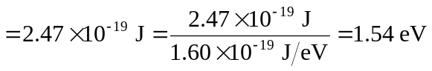
b) 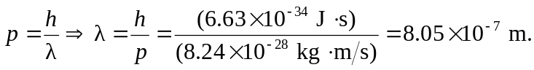
This is infrared radiation.

